CS LAB 1 ASSIGNMENT

Q1. Print "Merry Christmas !! Happy New Year 2023" using for, while and do-while loops ,7 times print?

Ans:

Using for loop:

#include <stdio.h>

int main() {

int i=0;

for(i=0;i<7;i++)

{

printf("Merry Christmas !! Happy New Year 2023\n");

}

return 0;}

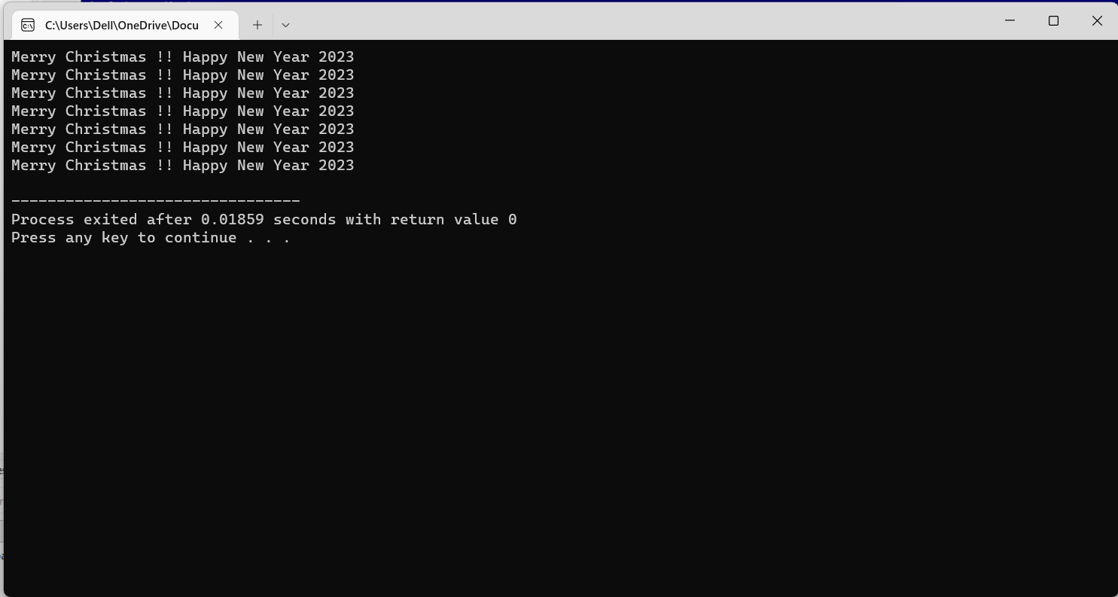

Using while loop:

#include <stdio.h>

int main() {

int i=0;

while(i<7){

printf("Merry Christmas !! Happy New Year 2023\n");

i++;

}

return 0;

}

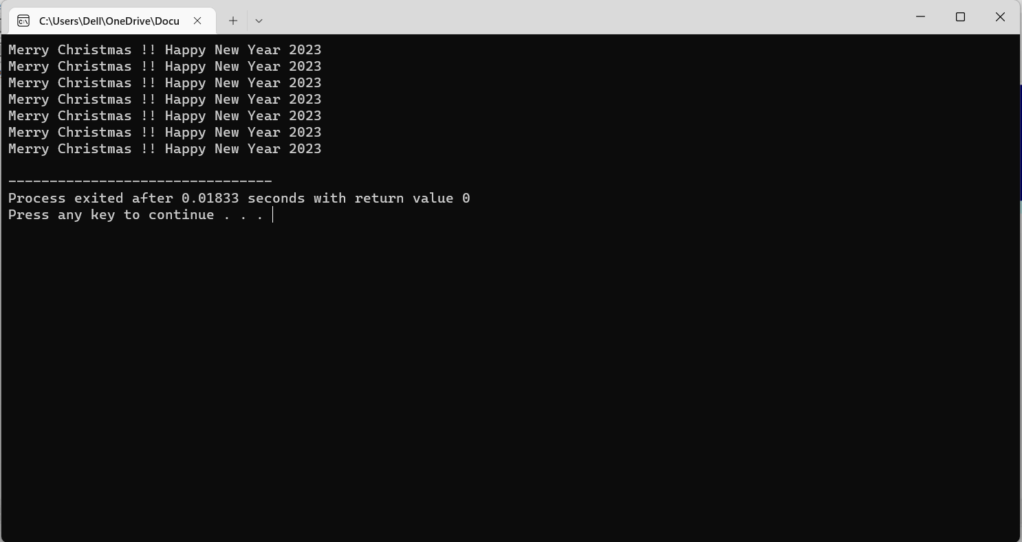

Using do while loop:

#include <stdio.h>

int main() {

int i=0;

do

{

printf("Merry Christmas !! Happy New Year 2023\n");

i++;

}while(i<7);

return 0;

}

